

Students on the Go, Safely and Independently—
A Travel Training Manual

The printing of this publication was supported by federal funding. This publication shall not imply approval or acceptance by the U.S. Department of Education of the findings, conclusions, or recommendations herein. Gallaudet University is an equal opportunity employer/educational institution, and does not discriminate on the basis of race, color, sex, national origin, religion, age, hearing status, disability, covered veteran status, marital status, personal appearance, sexual orientation, family responsibilities, matriculation, political affiliation, source of income, place of business or residence, pregnancy, childbirth, or any other unlawful basis.

A Travel Training Protocol
(What To Do Before, During, and After Travel Training)

Before the training:

- Determine who initiated the request for travel training for a specific student and confirm that this is consistent with the regulations and policies of your school or school district. The travel training plan must be consistent with these regulations and policies to ensure the student’s safety and well-being throughout the training.

- Obtain parent/guardian permission before training begins (Appendix A). Make sure that the Emergency Contact Form (Appendix B) and the Family Plan—Unexpected Travel Events Form (Appendix C) are in place.

- Establish goals for the training in consultation with the parent/guardian, the student (as appropriate) and the designated school personnel. What does the student need to know to travel independently and safely from one point to another? Appendix D describes what is typically covered during travel training. However, the training must be suited to respond to the individual needs of each student.

- Check the student’s file. Pay particular attention to the psychological evaluation reports, medical reports, memo on restrictions, etc. These documents may contain information that will impact the student’s safety during the training or his/her ability to retain information during the training process. Note these concerns in the travel training plan and make provisions on how to address them.

- Consult with the student’s teachers and relevant staff members if they have other information that may impact travel training.

6. If the student needs reduced fare cards for the bus, subway, or train, start the application process before any training transpires. Consult the local transportation authority regarding the availability of half-fare or discounts for persons with disabilities and the requirements for application. In most cases, a government-issued identification, a copy of birth certificate or social security card is acceptable forms of identification. An applicant may be required to show a recent audiogram as well.

7. Map out the best route to and from the travel destinations. The local transportation authority website is a good reference. Consulting with parents/guardians can help the trainer determine the quickest and safest route, and possibly one most familiar with the student. Confirm the final route with the parents/guardians as written on the Parent/Guardian Permission Form (see Appendix A). Encourage the parents/guardians to review the route at home with their children.

8. When the route is finalized, coordinate with the student’s family, teachers, and designated school personnel to schedule the travel training dates. Travel training is never completed in one day. Ample time must be allocated to assess what the student already knows and evaluate what he/she is learning. Typically travel training happens over three-four days. Days vary depending on schedules and the student’s ability to process information.

9. Prior to the training, conduct a pre-assessment of the student’s commuting experience and knowledge (see Appendix E). In this meeting explain the goals and objectives of travel training and what he/she will learn during the training days.

10. Assign the student to check the weather report for each day of training so that he/she can plan to wear weather-appropriate clothing.

During the Training:

Travel training occurs in a span of three to four days. On the first day of training, the student will experience the steps involved in traveling independently and safely as instructed by the trainer. On the second and succeeding days, the student will follow the steps from the previous day, with the trainer providing immediate feedback. As a final activity on the road, the student will travel independently and safely, with the trainer observing unobtrusively from a distance.

- Explain bus and/or train schedules and pick-up points. If you use a school or a shuttle bus to bring you to a main terminal, explain its schedules and pick-up points as well. Provide the student with a copy of these schedules if they are available.

- During the training, safety must be emphasized. Include safety precautions the student needs to internalize when going through bus terminals, train stations, and airports. Because many people use these stations/airports to commute, to shop, and to socialize, they can be overwhelming for someone who is learning to travel independently and safely. Teach the student where and how to access help in these places if there is a need.

- At this point, assess the student’s ability to communicate with non-signing individuals. The ability to communicate with people who do not use sign language is an important aspect of traveling independently and safely. If you sense that the student does not have the skills to communicate with non-signing individuals, engage him/her in role play to demonstrate different communication strategies. Examples of communication strategies commonly used by deaf or hard of hearing people include, but are not limited to vocalizing, writing (with a pen and pad), pointing and gesturing, using a computer screen and keyboard, or pagers.

- If the student’s travel training includes using a subway system, help the student locate the station manager’s booth before using the system. If the student’s travel training includes the use of the airport or bus terminal, help him/her locate the traveler’s information booth before checking in or riding the bus. Knowing where the station manager’s booth and information desk are located is important so the student remembers where to go for help along the way. Remind the student to employ the different strategies in communicating with the station manager, security, police, or the information desk clerk. In a metro bus, the driver acts as the point person who can assist the student.

- Demonstrate where and how the student can purchase reduced fare cards/tokens at subway or train stations. Each transit system has similar fare card/ticket pass machines in their respective stations and designated stops. Some transit systems allow reduced fare card holders to add money to their fare cards using regular machines. If this is so, let the student demonstrate how to add more money to a fare card using the regular machines at the station. Other transit systems require that reduced fare card holders buy them at specific stations or from authorized vendors only. If the station has an authorized vendor, have the student experience buying a reduced fare card while in training.

- Teach the student how to check/read the transit system maps. Let the student practice reading the map to locate the station stop, fare amount, total travel time, and his/her final destination on the desired line. When training involves airport travel, teach the student how to read the arrivals/departures notice boards to confirm his/her flight status and gate information.

- Unless the student starts where the route begins, he/she must know the direction of the bus, subway or train to his/her the destination. Using the transit map (available in print or posted in stations), teach the student how to determine which direction of the bus or train to board to his/her final destination. Some cities have electronic message boards that announce the arrival of trains and important commuter information (i.e., bus or train delays, station closures, elevator repairs, etc).

- Point out the safety features within the platform or waiting area before leaving the station. Help the student locate the emergency telephones and exits.

- Inside the train, orient the student to the different parts of the coach: doorways, station maps, seats for individuals with disabilities and the elderly, emergency exits, etc. Teach the student how to identify station stops from inside the train by looking at transit maps or the list of station stops posted.

- If commuting involves the use of transfer tickets (bus-to-bus, subway-to-bus, bus-to-subway), the student needs to know where to get and how to use them. This will help the student minimize the cost of commuting. Inside a bus, transfer tickets are given by the driver as the passenger boards. Inside subway stations, transfer tickets are available from dispensing machines.

- When using the bus or train, the student needs to know:
- Bus/Train stop locations
- Bus/Train number/s
- Fare information (Exact change required? Tokens?)
- The direction of the bus/train he/she should take
- How to alert the bus driver/train conductor that he/she needs to get off
- Street crossing procedures
- Travel safety tips and procedures (See Appendix F).

- If travel training includes air travel, the student needs to know the following:
- Arrival at the airport (at least two hours before the scheduled departure).
- Check in procedures (on-line vs. in-person; curbside vs. automated).
- Security-screening procedures (what goes through the x-ray machines; risks related to cochlear implants or shunts in the student’s person; what to do when flagged for thorough search, etc).
- Inform the airline grounds crew he/she is deaf and needs to be approached when boarding starts or when changes in the schedule occur.
- What to do in cases of emergency at the airport, en route to, or at the destination.
- Multiple layovers, including gate and airplane changes (boarding passes, gate information, schedule changes/updates).
- Baggage claim and carry-on luggage.
- Meeting family/friends upon arrival.
- Travel safety tips and procedures (See Appendix F).

- While en route to the destination, let the student observe the behavior of his/her fellow commuters. Encourage questions from him/her. Engage him/her in conversation about traveling independently and safely.

- When the trainer and student arrive at the destination (i.e., home), make sure that the trainer speaks with the parent or guardian to provide a summary of what transpired during the travel training. Share successes and concerns or ask questions. Let parents and guardians ask questions or share their concerns. Encourage them to sit with their child and let him/her explained what happened. This approach will help the student retain as much information as possible. At the same time, it will provide parents and guardians with feedback that they can share with the trainer.

- Document each day of the training, especially what needs to be reviewed or emphasized during the succeeding days or after the training is completed. If there are concerns or issues that come up or are raised by the parents and guardians, include these in the documentation as well. (See Appendix G.)

- Using the travel training checklist (Appendix H), review what the student has learned from the training—start this on the second and succeeding days of training. Encourage the student to assess his/her progress as well.

- Travel training is completed when the student has aptly demonstrated his/her ability to travel independently and safely.

After the Training:

1. For objectivity, arrange for another staff member to meet with the student to conduct post-assessment (see Appendix I) and an evaluation (see Appendix J) of the travel training. If the student is able to fill out the two forms, let him/her do so; the staff member will facilitate and be available for questions. Otherwise, the staff member will record student responses on the form. Student feedback is essential in helping the trainer plan the succeeding training days.

2. Document student learning and progress after each day of training (see Appendix G). This will help other staff, teachers, and parents/guardians to know what the student has learned and what needs to be reinforced even after the training is completed.

- Provide feedback to parents/guardians and teachers about the student’s strengths and weaknesses while traveling. Parents/guardians can use this feedback to help their child practice and apply what they have learned when they travel together. Teachers can use this feedback to provide reinforcements to the student inside the classroom.

- A certificate of completion may be given to the student at the conclusion of the training to recognize his/her accomplishment and to serve as a reminder that he/she can travel independently and safely.

Parent/Guardian Involvement and Measure of Success:

The goal of travel training is to teach the student to travel independently and safely. Among other factors, the involvement of parents/guardians is important to ensure that the student practices and applies what he/she has learned after the training is completed. Therefore, a measure of a successful training is a student who practices and applies the skills.

Throughout the travel training process, parents/guardians:

1. Must be included in designing and approving the travel route on which the training will be based.

2. Must have a copy of the travel training plans and receive constant updates or immediate feedback on their child’s progress during the training.

3. Must have direct access to the designated school personnel if they have questions or concerns about their child’s well-being.

4. Must be supported when they establish curfews and rules for their child to follow in emergency situations.

5. Must be encouraged to provide opportunities for their child to practice and apply the skills he/she learned in the training.

Today’s Date

Name of Parent/Guardian
Address
City, State, ZIP

Dear Parent/Guardian:

The members of the Transition Team have prepared a travel training curriculum to teach students how to use the public transportation system in the (identify the geographical area) and surrounding metro areas. We believe that independent and safe travel is an important part of any child’s transition.

We want to make travel training available to your child. Enclosed are handouts explaining aspects of the training. If you feel that your child will benefit from this and want your child to receive training, please complete the permission form attached and send it back to me. We will try to schedule the travel training during ________________.

If you have any questions, please contact (designated school personnel).

Sincerely,

(Designated School Personnel)

Enclosures

Appendix A
Parent/Guardian Permission Form

Parent/Guardian Permission Form

My child, ____________________________, has my permission to receive travel training from (school name and department). He/she will learn how to use the (identify which local transit system) independently and safely. I understand that I will receive information on my child’s progress from (designated school personnel).

My child will learn how to travel independently and safely to and from (choose what is appropriate):
___ home to school, and vice-versa

___ school to another location. Please specify location: _________________________

___ after-school program to home. Please specify program: _____________________

___ other locations. Please specify: ________________________________________

The route I prefer my child to learn is:
________________________________________________________________________________________________________________________________________________

I will call or write the (designated school personnel) if I remember some other information that will help plan a better and more effective training.
__________________________________________ _______________________
Parent’s/Guardian’s name and signature Date

__________________________________________ ________________________

Designated School Personnel’s name and signature Date

Appendix B
Emergency Contact Form

Travel Training Emergency Contact Information

This form will be completed by parents/guardians. The Designated School Personnel will teach the student when to use the information and how to safeguard its contents. The student will keep a copy of this in his/her possession at all times. The school encourages families to write a “Family Plan” that their children will follow when an unexpected travel situation occurs. (See Appendix C).

Student Information:

First Name: _________________________ Last Name: _________________________

Address: _______________________________________________________________

City: ________________________ State: _______________ Zip: ______________

Telephone: ________________ Pager: _______________ Email: _________________

Parent/Guardian Information (Primary Contact):

First Name: _________________________ Last Name: _________________________

Address: _______________________________________________________________

City: ________________________ State: _______________ Zip: ______________

Telephone: ________________ Pager: _______________ Email: _________________

Work Telephone _________________________ Fax: __________________________

Secondary Contact Information:

Name: __________________________________ Relationship: __________________

Address: _______________________________________________________________

City: ________________________ State: _______________ Zip: ______________

Telephone: ________________ Pager: _______________ Email: _________________

Work Telephone _________________________ Fax: __________________________

Appendix C
Family Plan—Unexpected Travel Events

Family Plan – Unexpected Travel Events

A vital part of Travel Training is to learn about safe traveling. The (designated school personnel) will teach your child how to stay safe while en route to and from school or any destination that you have approved. The (designated school personnel) will also teach your child what you, as parents/guardians, have written on the Family Plan and want him/her to follow when he/she is unable to complete her commute due to unforeseen circumstances. With a Family Plan in place, your child will learn to follow what you have written when unexpected events occur. These events may include subway, train, or bus delays for whatever reason; missed train, bus, or flight connections; trip cancellations due to inclement weather; and other unforeseen circumstances.

The Family Plan gives directions to your child on what to do and whom to contact should an unexpected event occur. The plan should list all the name/s of designated contact/s, and their contact information (e.g., pager addresses, telephone numbers, addresses, etc.). The (designated school personnel) will instruct your child to become familiar with its contents and to have a copy of it in his/her person at all times. To reinforce its importance, please review the contents of the Family Plan with your child, other members of your family and anyone who is listed as a contact. The (designated school personnel) will also keep a copy of the Family Plan in your child’s central file.

To serve as your guide, you can use the following outline or develop your own plan. Please return the completed and signed Family Plan to the school before travel training begins.

What student must do. . . | Family Plan | Contact Information
If stranded at a subway station:

If stranded at a bus stop/station:

If stranded at the train station:

If stranded at the airport:

If stranded in the school/dorms:

If stranded at the shopping mall:

If cannot take any public transport system:
If scared or feels unsafe:
If fare card or money is lost:

_________________________________________ ________________________
Parent’s or Guardian’s Signature Today’s Date

Appendix D
What Do You Do During Travel Training?

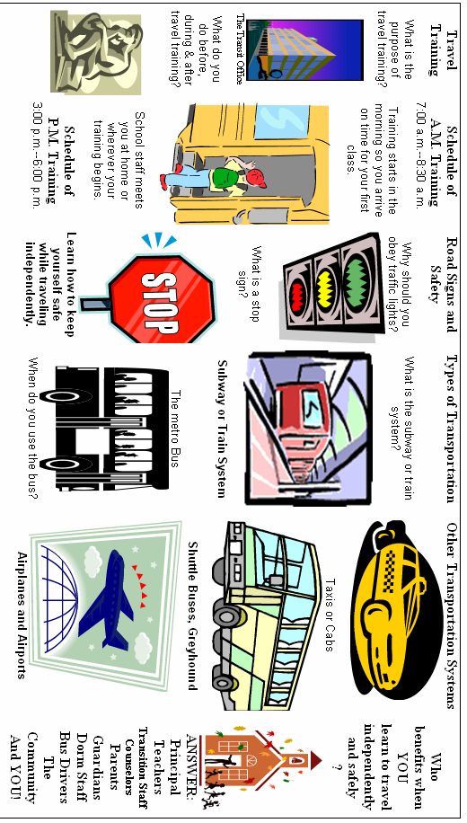
What Do You Do During Travel Training?

Appendix E
Pre-Assessment Guide Questions

Travel Training Pre-Assessment Guide Questions

Name of Student: ______________________________________

Team: ____________________________________________
Facilitated by: ______________________________________
Date: __________________________________________________

Question | Note responses here
- What is your address? (Include city, state, and zip code)
- Do you have a reduced or half-fare card ID? What is this for?
- Have you ever taken the subway, bus or any public transportation alone? (If the response is NO, skip to #8-15 then STOP)
- If you have, where did you go?
- How often do you use the subway, bus or any public transportation?
- Where do you go on the subway, bus or any public transportation?
- Describe how you go home using the subway, bus or any public transportation.
- If you want to cross the street, what must you do first (before you cross)?
- What is a stop sign?
- What are traffic lights?
- If you are at an intersection with a stop sign, when is it safe to cross the street?
- If you are at an intersection with a traffic light, when is it safe to cross the street?
- Using the subway map, how many lines (routes) are there in the subway system?
- How do you know which bus to take to where you want to go?
- If you want to go shopping at a mall (store), where do you go and how do you get there?
- If you are inside the metro station and your fare card won’t work, whom do you approach for help?
- You are ready to get out of the metro station, but your fare card needs more money. What do you do?
- If you are inside the bus, and you need to get off soon, how do you let the bus driver know?
- What is a bus transfer ticket? Where do you get it? When can you use your bus transfer?
- What is a subway transfer ticket? Where do you get it? When can you use it?
- What is an emergency? Give me an example of an emergency situation.
- You have a list of emergency contact numbers with you or in your school bag. How will you contact your family in an emergency?
- Suppose you are inside the subway station waiting for the train. Suddenly you see people running towards the nearest exit. What would you do?
- Suppose you are inside a city bus on your way to school. A passenger sits next to you and starts to bother you. What would you do?
- Suppose you are waiting for your flight to go home for the holiday. You went to the store to buy a drink. When you returned to your gate, you realized that you missed your flight. What would you do?

Appendix F
Travel Guide
Travel Guide (wallet-size version)
& Safety Tips and Precautions

Travel Guide
(A reminder for students)

To make your travel experience safe and successful, communication is important. Make sure that you have your family and friend’s phone and pager information with you at all times while traveling.

It is your responsibility to get written permission from your parent/guardian when you plan to go to a friend’s home or when you make changes to your plan to go home.

Always have extra cash with you in case of an emergency. You never know if your trip takes longer than you expect or if your bus, train or plane is delayed, cancelled or your schedule changes. With extra cash, you can buy food or have money to pay for a cab if necessary.

Know your schedule and travel times. Write them down and keep them with you all the time. Do not keep them in your suitcase.

If you seem lost or unsure of what to do while traveling, please ASK for help from ticket agents, bus, train or airport staff, and security officers. Have your pen and paper ready to write down what kind of help you need.

Remember to relax while traveling so you can enjoy yourself. Know whom to ask for help and what kind of help you need from others.

(FRONT)

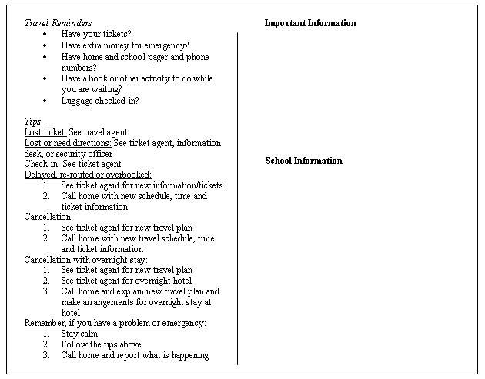
(BACK)

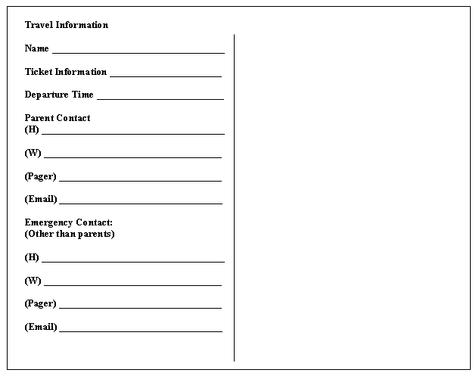

TRAVEL SAFETY TIPS AND PRECAUTIONS
Adapted from the Washington Metropolitan Transit Authority and
the Metropolitan Washington Airports Authority

- ALWAYS STAY ALERT: Pay attention to what is happening around you. Keep your belongings with you at all times.

- Keep your eyes open all the time. Don’t sleep on the train, bus or any public transportation. Wait until you get to your destination safely.

- When traveling in groups, let your group mates know where you are going if you plan to separate from the rest. Or better yet DO NOT SEPARATE from your group if you can avoid it.

- To make TTY calls, look for the TTY machines in a bus or train station. If you cannot find one or if the TTY is broken, ask the help of the station manager, bus driver or airport information clerk.

- Use your Emergency Contact Form and your Family Plan in contacting your family about your whereabouts. Use your pager if you have one.

- Video cameras are installed in subway, bus, and train stations as well as airport terminals to monitor your safety and all kinds of activities in the system. Don’t hesitate to react if your safety is threatened so that others may help you.

Do you have a Communication Plan?

- At the train or subway station, airport or the bus terminal, have a pad and pencil handy with you at all time to help you communicate to people who do not know sign language.

- If you have a pager, use your pager to communicate back and forth. BUT remember, pagers only work above ground or where signals are strong.

- Create your own Travel Communication Cards. Using 3x5 index cards, write down questions that you might need when traveling. Laminate each card or protect it with a plastic cover. Then punch a hole through each card where a key ring can be inserted to bind your cards together. Add more cards as you think of more questions that come up when you travel.

When Using the Escalator

- Hold on to the handrails to keep your balance. Do not ride or lean on the handrail or play while on the escalator. Do not sit on the escalator steps.

- Always stand straight. Keep your hands, feet and clothing away from any moving parts.

- Do not drag your feet off the escalator steps.

- When you reach the bottom or the top of the escalator, exit immediately. Do not stop or play.

When Using Trains or At the Train Station

- Know where the emergency exits are inside the train. During an emergency, written instructions will be electronically displayed inside the train and in train stations.

- When waiting for a train, stand near other passengers. Do not stand on the platform edge.

- When train doors are closing, do not try to enter the train because you can get caught while doing so.

- Do not loiter in the platform area after exiting the train.

- Do not display expensive jewelry or items when traveling. Hold on to your purse, and be careful with your backpack and wallets.

- If you need directions or help, ask the station manager.

If You are Lost

- Go to the information or help desk, ticket counter or security/police officer and ask for help.

- Tell them that you are lost. Show them your ticket and they will guide you to where you need to be or to board your bus, train or plane.

If You Misplace or Lose Your Ticket or Boarding Pass

- Go to the nearest ticket counter and explain your situation.

- Be ready to show your photo ID to the ticket agent who will check if your name is on the list of passengers. Your ticket or boarding pass will be re-issued only with a photo ID.

When Using Buses or At Bus Stations

- If an emergency happens while you are inside a bus or at a bus station, DO NOT PANIC. Bus drivers and station personnel are trained to get help immediately. Wait for further instructions from them and from the police.

- If you need help or have a problem while on a bus, write a note to the driver or the conductor. Using your Travel Communication Cards, explain what you need or the problem that you have to the driver or conductor.

When Traveling by Air or Waiting at Airport Terminals

- Before you leave for the airport, check your airline’s website for the status of your flight. This will help you avoid long waits in case your flight is delayed or cancelled.

- Make sure you have a government-issued picture ID before you leave for the airport. Examples are: driver’s license, non-driver’s ID, passport, etc. Your school ID is not acceptable.

- Arrive at the airport at least two hours before your scheduled flight to allow time to check-in and to complete all security screenings.

On-line, Curb-side, or Self-Service Check-in at the Airport

- You can use on-line check-in for your flight within 24 hours of your departure. Go to your airline’s website and follow the instructions for on-line check in. Print your boarding passes. You can use these boarding passes to check-in any luggage and to board your flight.

- Curbside check-in. This is the easiest way to check yourself in with your luggage. Show your printed boarding pass (if you printed one) and your ID to the curb side attendant. He/she will check your luggage in. By using curb-side check-in, you avoid long waits at the check-in counters. (Be sure you tip a curbside attendant).

- Self-service check-in at the airport. Inside the terminal are self-service check-in kiosks. You will need a state-issued ID or a credit/debit card so the machine can verify your identity. Follow on-screen instructions. An airline representative will give your boarding passes after you have satisfied all check-in requirements. (No tips here).

Clearing Security before Your Flight

- After checking-in, go through the security check point immediately. You must have your boarding pass and ID ready for inspection before you can clear security.

- Strict security procedures are in place for the safety of each flight. Depending on the level of threat to passenger security, the TSA (Transportation Security Administration) has set guidelines on what passengers can take on board an airplane. For the most recent list of items that are not allowed and for items that you can carry on the plane, check: (http://www.tsa.gov/travelers/airtravel/prohibited/permitted-prohibited-items.shtm#0)

- All passengers and their carry-on bags must clear security before boarding any flight. The following items must pass through the x-ray machine at the security check point:
  - ALL items in your pocket including pager, cell phone, keys, wallet, or any loose objects must be placed in a plastic bin to be x-rayed.
  - Notebook computers must be placed in plastic bins to be x-rayed.
  - Your carry-on bag, shoes (any kind), jackets, coats, or any outer garments must go through the x-ray machine.
  - All liquids, gels and aerosols (up to 3 ounces) must be placed in a single, quart-size, zip-top, clear plastic bag (not bigger) and removed from your carry-on to be x-rayed.

- If you wear hearing aids or have a cochlear implant, it is safe to go through the metal detectors. If you choose not to go through the metal detectors, request for a full-body search. Use your Travel Communication Cards to help you explain.

- If you travel with a hearing dog or a service animal that must remain with you at all times, inform the TSA security screeners so they can help you. Show proper documentation supporting the need for a hearing dog or a service animal.

- If you have prescription medication, any over-the-counter medication, liquids or gels, a needle or a syringe, place them in a separate bag properly identified and declare them to the TSA security screeners. Professional packaging or a pharmaceutical label will help identify what you are taking with you on board. There is no limit to how much of these you can bring with medical documentation.

- Remove any kind of lighters and sharp objects longer than 4 inches, such as knives and scissors, from your carry-on bag.

- Travel light. Limit your carry-on item to one, plus a purse or a briefcase.

- After clearing security, go directly to your gate. Make sure that you have your boarding pass with you. Put your ID back in your wallet because you will not need it anymore.

Waiting at the Gate for your Flight

- When you arrive at the gate, inform the gate agent that you are deaf. Use your Travel Communication Cards to explain that you need to be informed of any announcements related to your flight, especially if your trip has been re-routed, delayed or cancelled.

- Do not hesitate to remind the gate agent that you are waiting to board your flight. Stay close to where they can see you. Because they deal with many passengers, it is easy to forget about you.

- Look for a TV monitor or screen close to your gate that provides flight updates and information. Check it frequently while waiting for any flight information. Do not just depend on the gate agent for information.

Trip Cancellations

- When your bus, train or flight is cancelled due to bad weather or some other reason, ask help from the bus, train or airline representative. They will try to book you on the next available trip.

- When you have a new departure schedule, call home and let them know of the changes in your trip. Provide them with your new departure schedule.

- If there are no other trips available for the same day, the ticket agent will book you on the next trip the following day.

- If cancellation is weather-related, airlines do not have to pay for your hotel. But you can ask for help especially if you do not have money to pay for a hotel.

- Call home and let them know your trip has been cancelled for the day. Let your family know if you are going to a hotel or if you will need a place to stay for the night.

When traveling always remember to relax and enjoy the trip. If you have a problem or an emergency:

- Stay calm.
- Follow the tips in your wallet.
- Call home and keep them updated.
- Ask for HELP.

Appendix G
Progress Report Form

Travel Training Progress Report

DATE/TIME | SKILLS  (INTRODUCED OR REINFORCED) | OBSERVATIONS  (USE BEHAVIORAL TERMS ONLY) | RECOMMENDATIONS

Completed by:________________________ Date:_____________

Appendix H
Travel Training Checklist
Travel Training Checklist

This checklist serves as a reminder for the designated school personnel to cover the main aspects of the travel training with his or her student.

- Obtain permission from parents/guardians for travel training.
- Ensure that student has a train/bus pass or reduced fare card.
- To map out the best route to and from the travel destinations, consult with parents/guardians, and check the website of the local transportation system in your area.
- Confer with teachers, transition staff, or other designated school personnel about the travel training dates.
- Before first day of training begins, conduct the pre-assessment evaluation.
- Set the schedule for the training with student.
- Check weather report around the day/s of training to ensure that the student wears the appropriate clothing.

Review:
- Where and how to purchase fare cards/tokens.
- Transfer tickets and the rules governing its use from train to bus and bus to bus (including its validity period).
- How to check/read train/bus map or flight schedules and itineraries.
- How to use a fare card to enter metro or subway stations.
- How to add money to a fare card.
- Bus stop locations.
- Which direction of the train or bus to take to the destination.
- How to alert the driver of a bus that you want to get off.
- What to be alert about when taking the train/bus to your destination.
- Crossing streets safely; transferring from one train or bus to another.
- Safety tips and precautions when traveling.
- School, home, and travel destination emergency contact information.
- How to find and use the emergency alert systems inside trains, train stations, buses, bus stations and airport terminals.

Remember:
- Ask your student questions along the way; engage him/her in conversation about traveling independently.
- Ask another staff member to facilitate the post-assessment test and program evaluation with the student.
- Document student progress.
- Provide feedback to parents, teachers and or other designated school personnel.
- Print certificate of completion and present it to the student (optional).

Appendix I
Post-Assessment Guide Questions

Travel Training Post-Assessment Guide Questions

Name of Student: ______________________________________

Team: ____________________________________________
Facilitated by: ______________________________________
Date: __________________________________________________

Question | Note responses here
- What is your address? (Include city, state, and zip code)
- What public transportation do you need to take to go home?
- If you want to cross the street, what must you do first (before you cross)?
- What is a stop sign?
- What are traffic lights?
- If you are at an intersection with a stop sign, when is it safe to cross the street?
- If you are at an intersection with a traffic light, when is it safe to cross the street?
- Using the subway map, how many lines (routes) are there in the subway system?
- How will you know which bus to take to where you need to go?
- If you want to go shopping at a mall (store), where do you go and how do you get there?
- If you are inside the subway station and your fare card won’t work, whom do you approach for help?
- What is a bus transfer ticket? Where do you get it? When can you use your bus transfer?
- What is a subway transfer ticket? Where do you get it? When can you use it?
- What is an emergency? Give me an example of an emergency situation.
- You have a list of emergency contact numbers with you or in your school bag. How will you contact your family in an emergency?
- Suppose you are inside the subway station waiting for the train. Suddenly you see people running towards the nearest exit. What would you do?
- Suppose you are inside a city bus on your way to school. A passenger sits next to you and starts to bother you. What would you do?
- Suppose you are waiting for your flight to go home for the holiday. You went to the store to buy a drink. When you returned to your gate, you realized that you missed your flight. What would you do?

Appendix J
Evaluation Questions

Travel Training Evaluation Questions

Use this evaluation in conjunction with the post-assessment guide questions.

- Describe how you felt during the travel training. (For example: Happy, scared, excited, bored, confident, inadequate, etc.)

- After going through several days of travel training, how do you feel about traveling independently now? Please explain.

- If you responded in #2 that you are not ready to travel independently yet, what do you think will help you to be ready?

- Where else do you want to go? Do you feel like you can map out the route and travel there successfully?

